Assignment 3
PNR: 260740150018
Name: PRATIK SUNIL ABHANG
Question:
Write a Python function to find the maximum of three numbers.
Program
def max_of_three(a=45, b=99, c=100):
return max(a, b, c)
print("Maximum using default values:", max_of_three())
a = int(input("Enter first number: "))
b = int(input("Enter second number: "))
c = int(input("Enter third number: "))
print("Maximum using user values:", max_of_three(a, b, c))

Input and Output
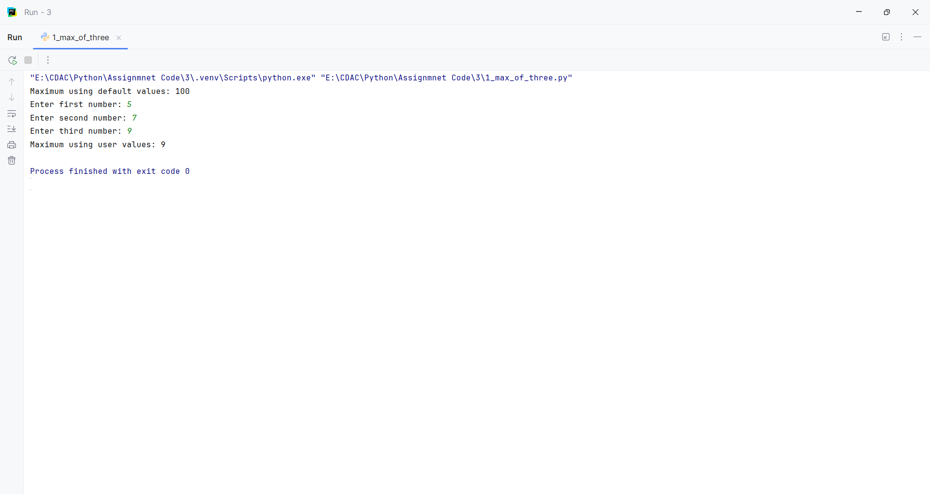
Question:
Create a function that takes a list of numbers and returns their sum.
Program
def sum_list(numbers):
return sum(numbers)
print(sum_list([1, 2, 3, 4, 5]))

Input and Output
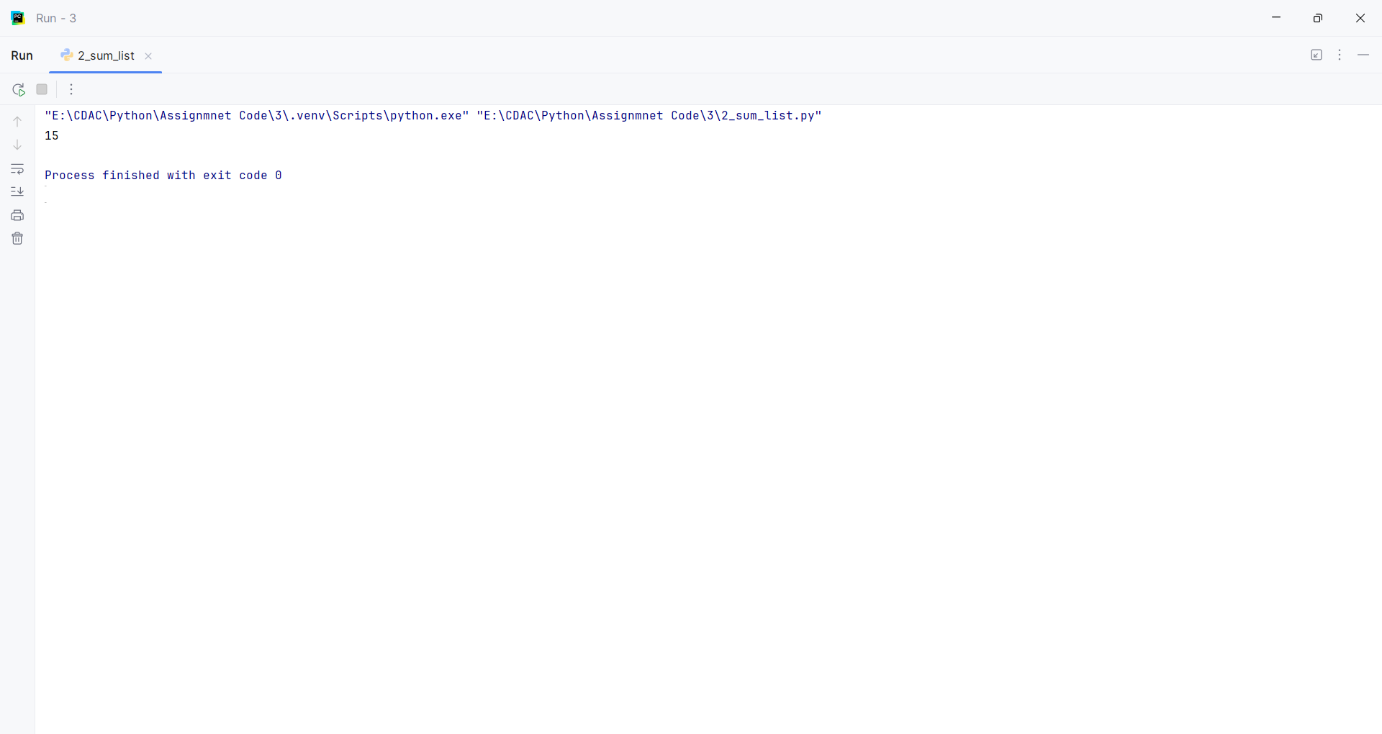
Question:
Write a function with a default argument that prints a greeting.
Program
def greet(name="World"):
print("Hello,", name)
greet()
name = input("Enter your name: ")
greet(name)

Input and Output
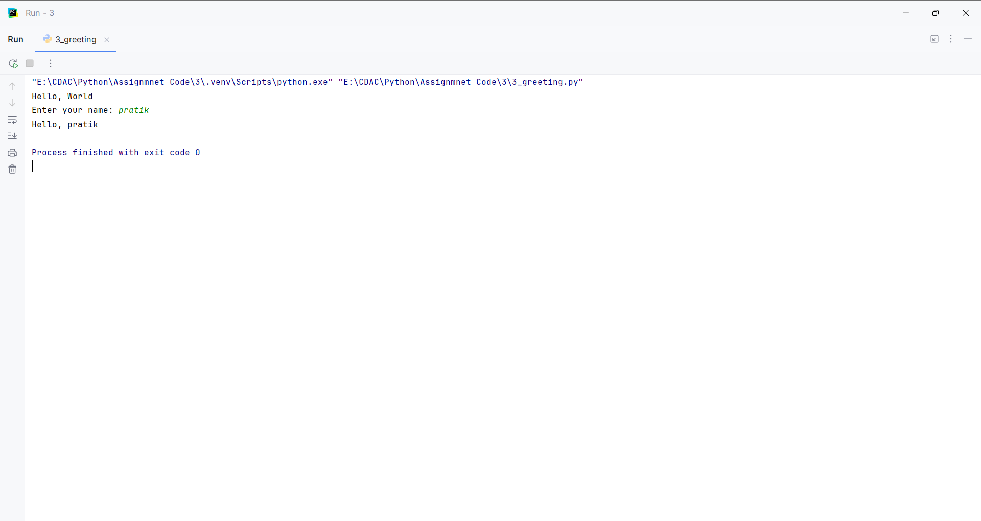
Question:
Write a function is_palindrome() that takes a string as an argument and returns True if the string is a palindrome (reads the same forward and backward) and False otherwise
Program
def is_palindrome(s):
return s == s[::-1]
text1 = "madam"
if is_palindrome(text1):
print(text1, "is Palindrome")
else:
print(text1, "is Not Palindrome")

Input and Output
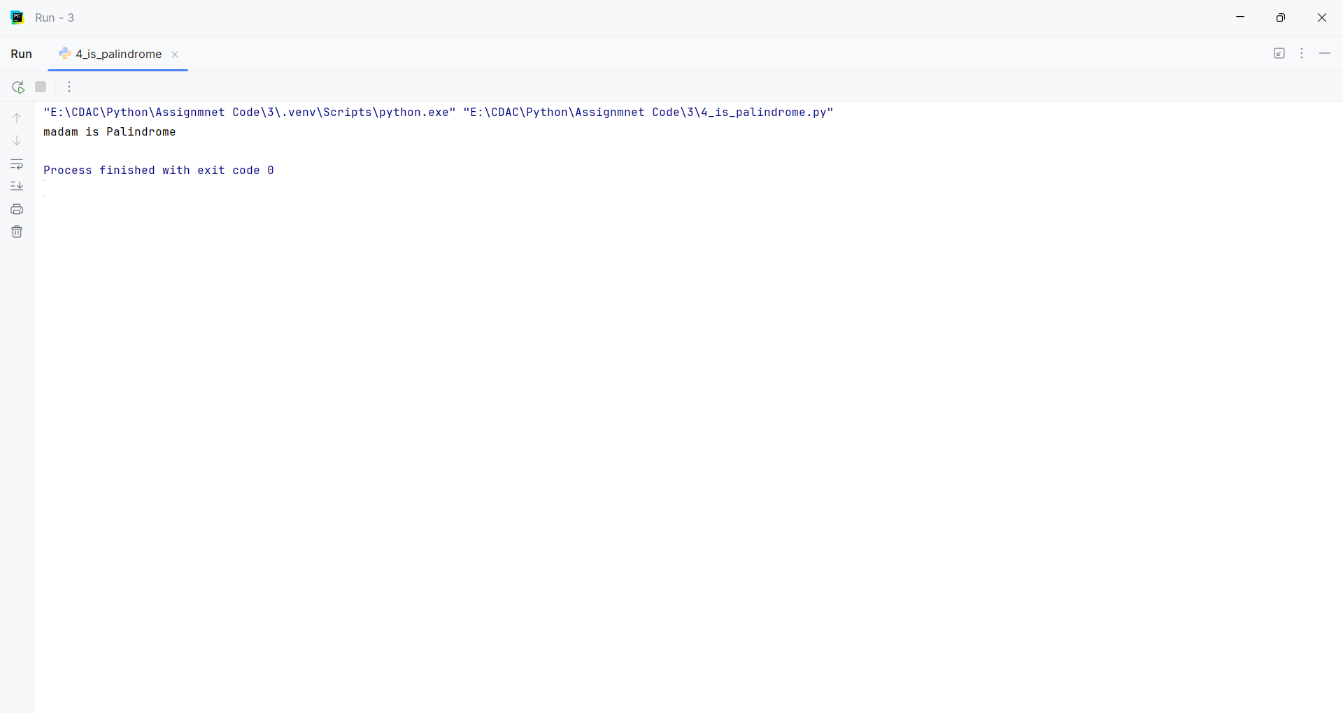
Question:
Write a function count_case() that accepts a string and returns a dictionary containing the count of uppercase and lowercase letters
Program
def count_case(s):
upper = 0
lower = 0
for ch in s:
if ch.isupper():
upper += 1
elif ch.islower():
lower += 1
else:
pass
print("Uppercase:", upper)
print("Lowercase:", lower)
text = input("Enter text: ")
count_case(text)

Input and Output
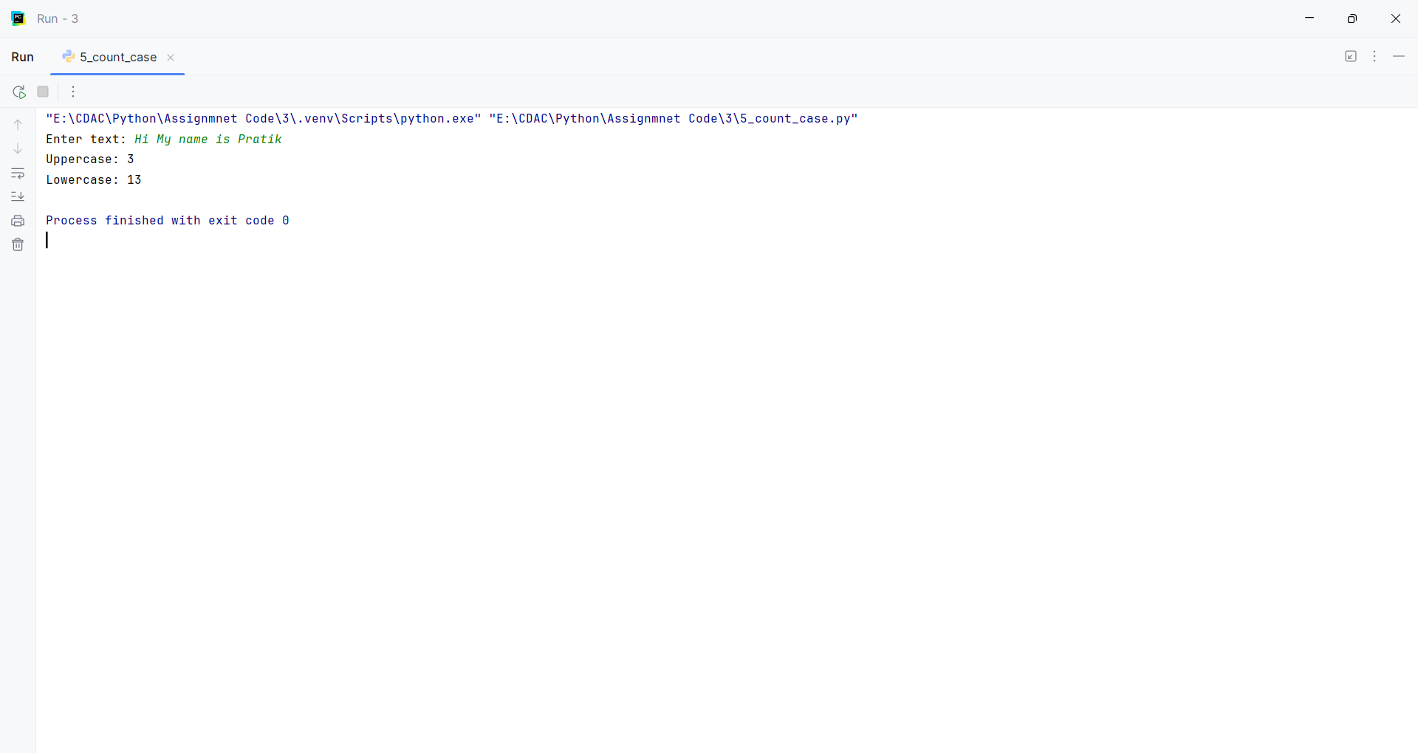
Question:
Write a function unique_list() that takes a list and returns a new list with distinct elements from the first list.
Program
def unique_list(lst):
return list(set(lst))
print(unique_list([1, 2, 2, 3, 3, 3, 4]))

Input and Output
